**Images of Vehicle Management System Using Salesforce Project**

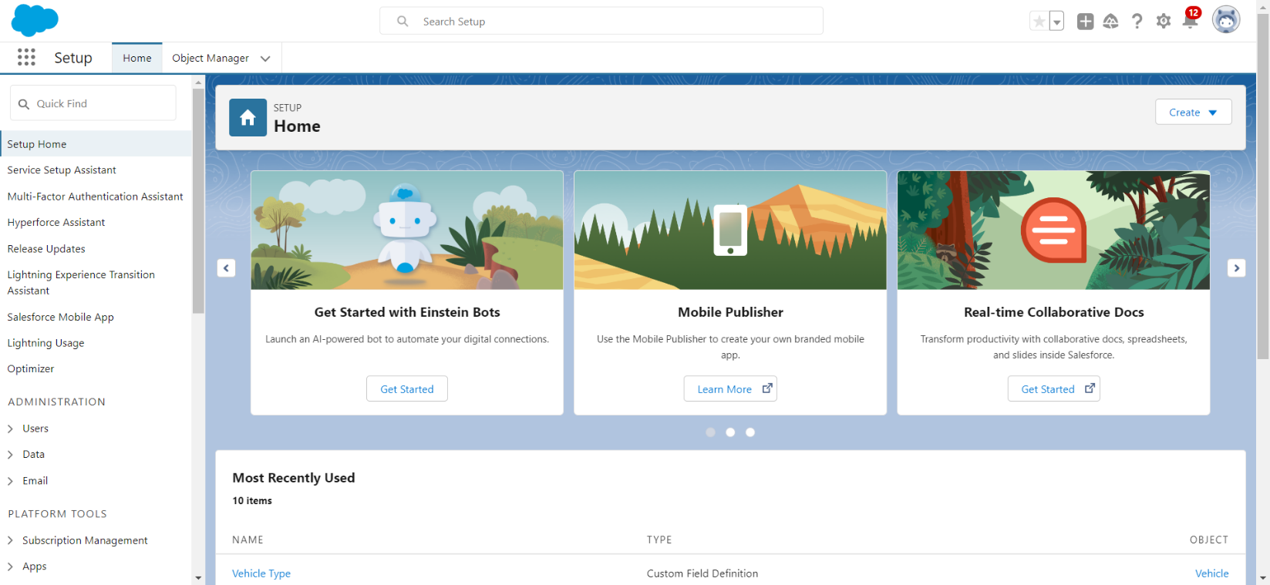

Created the Developer Account

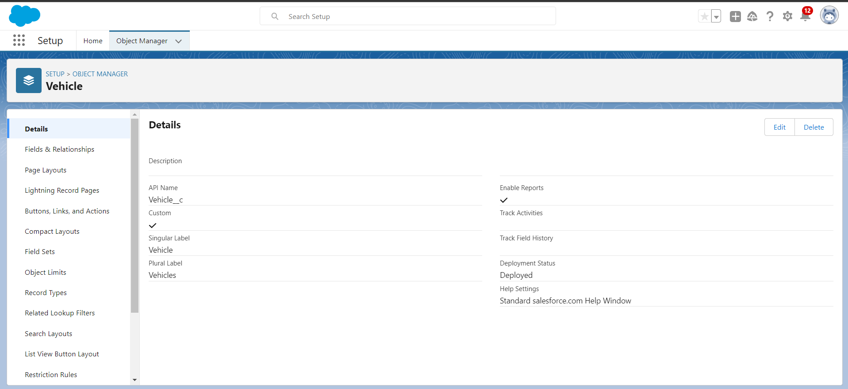

Created the Objects “Vehicle, Driver, Travelors”

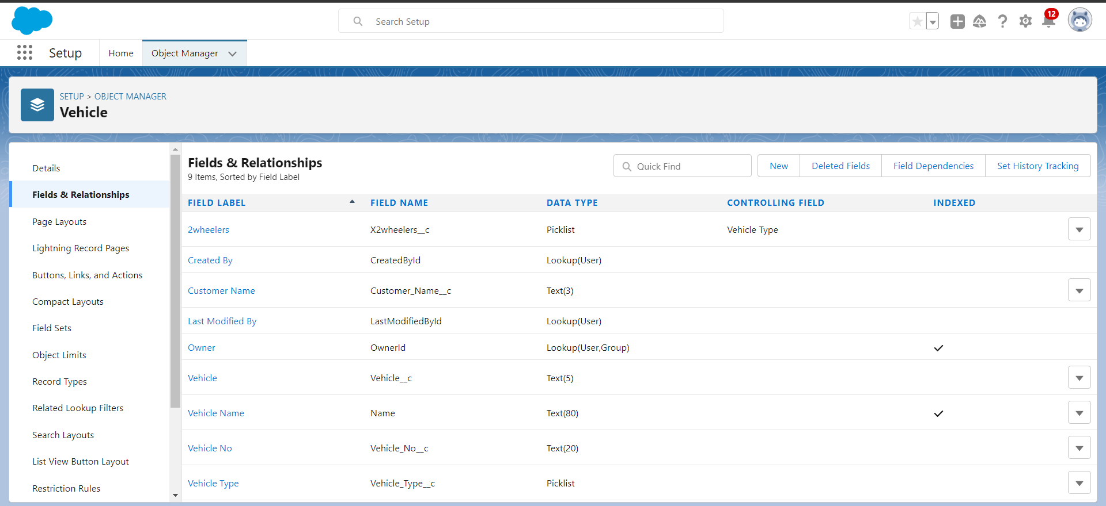

Created the Fields in Objects

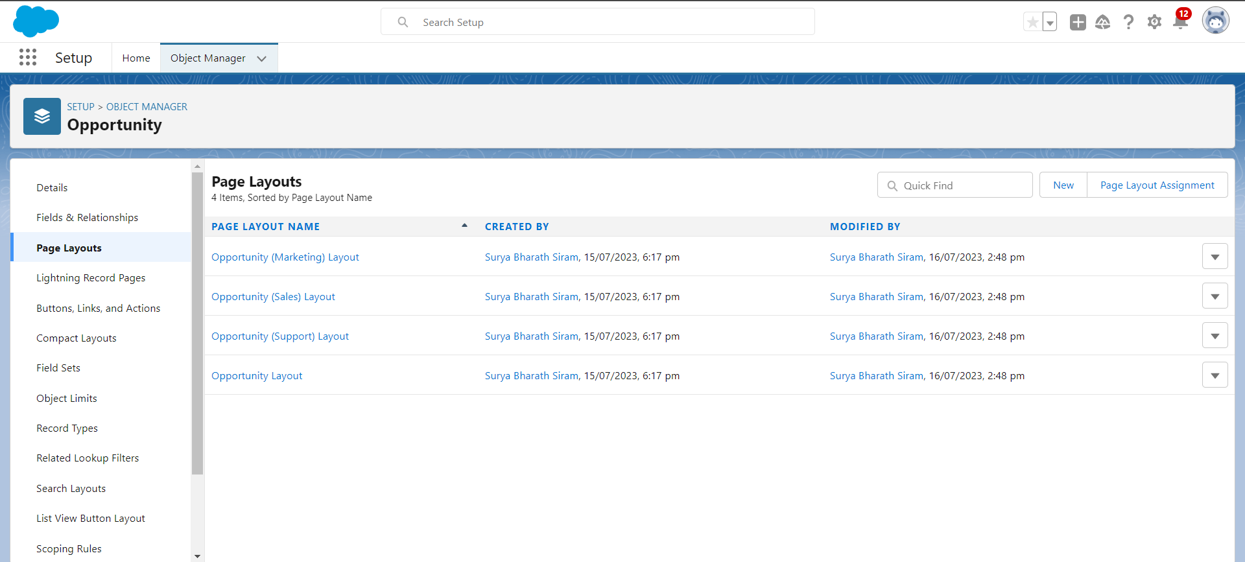

Created the Page Layouts in Opportunity

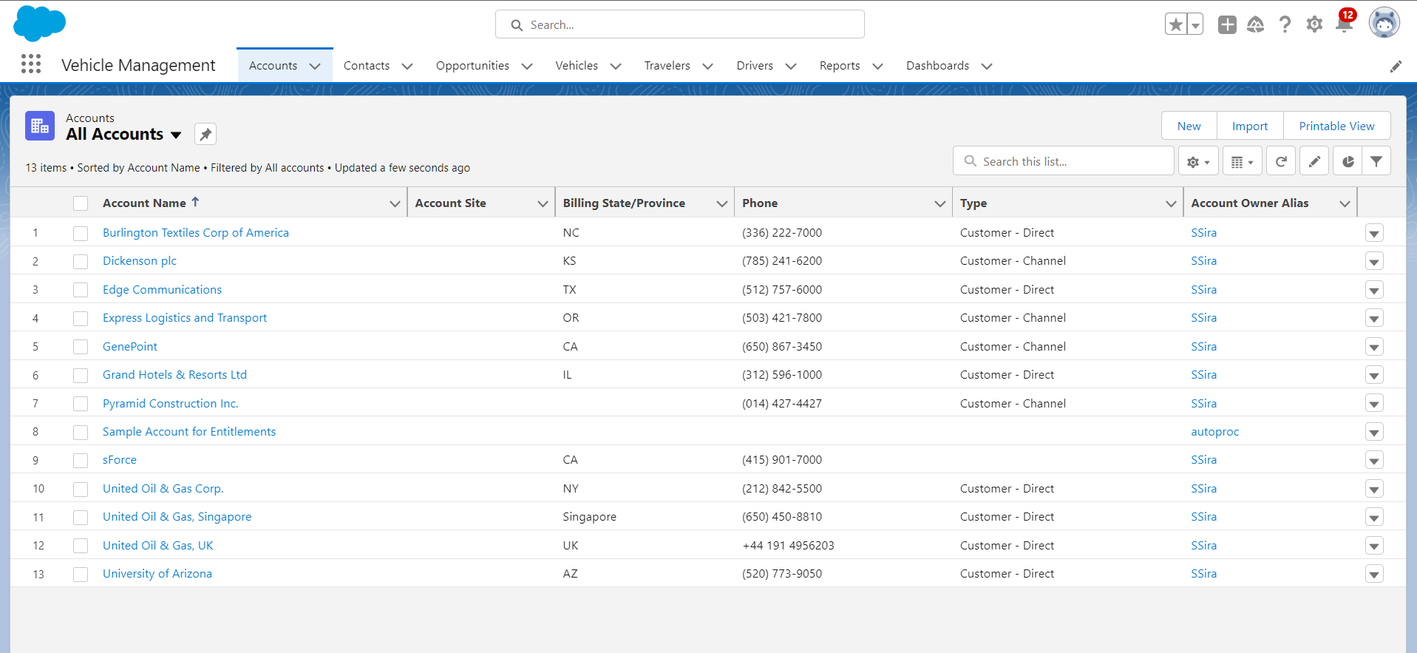

Created the Vehicle Management App

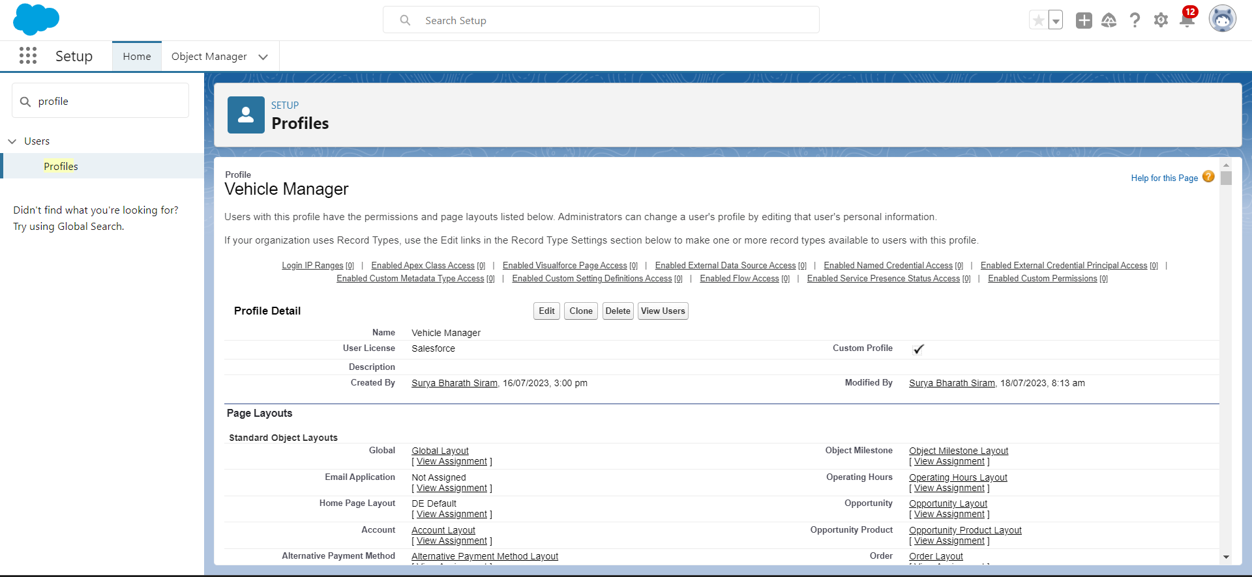

Created the Vehicle Manager Profile

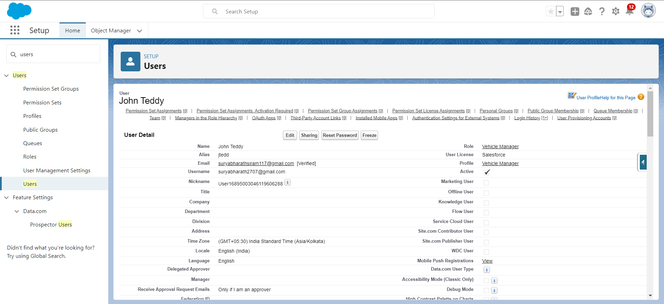

Created the User “John Teddy”

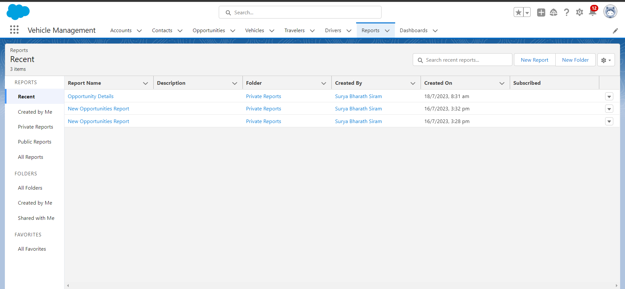

Reports In Vehicle Management App

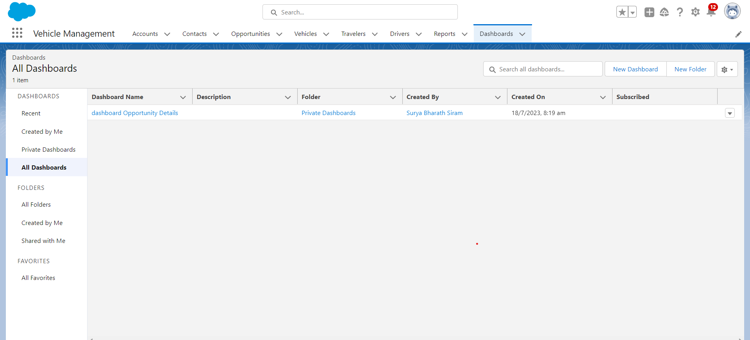

Dashboards In Vehicle Management App

THE END